Ethan Perdieu and Arthur Prete
CIT-37300
Target Market
February 6th, 2025

Role Breakdown:
Ethan: Demographics/Psychographics and Questions
Arthur: Research Summary and Questions

Primary Target Audience:
Young Families with Children (Ages 25-45)

Demographics:
Age:
- Parents: 25-45 years old
- Children: 2-12 years old
Gender:
- Experience appeals to all genders
Income Level:
- Middle Class
- ~ $50,000 - $100,000 household income
- ~ €58,000 - €117,000 household income (Euros since it’s based in the UK)
- Cheap and Leisurely, only £8.00 for adults and £5.00 for Children aged 2 - 16
Occupation:
- Does not tailor to a specific job, not much of a differentiator
- Flexibly Scheduled for weekend/holiday outings
Education Level:
- Does not tailor to a specific education level
Marital Status
- Married/Partnered (Primary Audience)
- Single Parents
- Couples
Family Size:
- 2-4 People (Most Common, 2 Children, 2 Parents)
- 5-6 People (Large Families, 4 Children, 2 Parents)
- 1-2 People (Couples)
Ethnicity:
- Does not tailor to a specific ethnicity
Location:
- Within 30-60 minutes surrounding the Location (Downe, Village)
- People located in London or close to London/Kent

Psychographics
Values:
- Family Bonding and creating memories
- Educational Experiences (Origin of Species from Charles Darwin)
- Outdoor Activities
- Supporting Local Businesses
Attitudes:
- Value Convenience (Has year-round availability other than Christmas, Allows dogs, On-site Refreshments and concessions)
- Relaxed Environments
- Quality family experiences
Personal Interests:
- Outdoor-Oriented Family
- Posts on Social Media Platforms
- Enjoys animals and farm visits

Specific Behaviors:
- Regularly has family outings
- Plans things during weekends or school holidays
- Leaves online reviews (Google Ratings or Trip Advisor)
- Share experiences on social media
Who they trust:
- Reviews like Google Ratings
- Bloggers
- Facebook Community Groups
- Word of Mouth from other Parents, Family or Friends
- Local News
What they read/watch:
- Reads Blog posts
- Local News (Metro/BBC News)
- Mumsnet (Popular UK Website for Parents) https://www.mumsnet.com/
- Facebook Community postings
Photos of some possible target market members (Family located in Bromley):
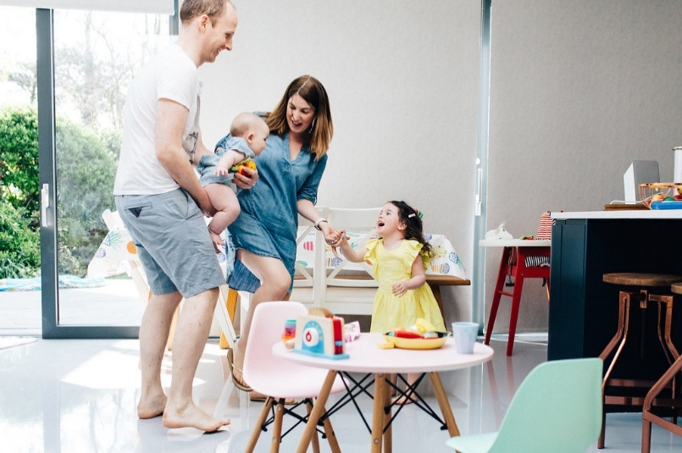

Questions:
I would say our target audience falls into the mainstream/reformer category. (4CS)
Ethan –
- When planning a family outing, what matters most to you?
- How much does the opinion of other parents influence your choice of family activities?
- Do you prioritize educational values when choosing family activities?
- How often do you return to the same family attraction?
- What prevents you from visiting some family attractions? (Distance, Cost etc.)

Arthur –
- What online platforms do you typically use to discover new family activities or attractions?
- When looking for a local attraction, do you rely more on website design, reviews, or social media presence?
- What factors would make you revisit or recommend an attraction to others?
- How important is accessibility (parking, public transport, stroller access) in your decision to visit a location?
- How likely are you to follow or interact with a family attraction’s social media page after visiting?

Summary:
Our research identifies young families with children aged 2–12 as the primary target audience. These families are typically middle class, living within commuting distance (30–60 minutes) of Downe Village or the London/Kent area. They are motivated by family bonding, educational value, and affordable experiences.
The attraction’s low admission cost and focus on nature, animals, and local heritage make it especially appealing to this demographic. The audience values convenience, quality time, and supporting local businesses, while also being active on social media, using platforms like Facebook, Instagram, and Mumsnet to find recommendations and share experiences.
Marketing strategies should therefore emphasize family fun, education, and authenticity, supported by strong online visibility and positive community engagement. Encouraging customer reviews and highlighting accessibility will strengthen trust and appeal among families planning weekend or holiday outings.

